Notes:

* This is a “LIVE“ document, i.e., more examples and items will be added to this document as we progress in the labs.
* Getting issues/error messages in the project set-up are often due to not following the lab document step-by-step carefully and/or not installing Java/JDL and the Eclipse IDE properly
* Each given issue/error message in the project set-up could be due to MANY possible root causes. We discuss the solution ideas that we are aware of. Students are encouraged to review online resources (such as StackOverflow) also which offer many other solution ideas as well.

# Technical FAQ (about software testing)

## Best practice for using assert() in test code

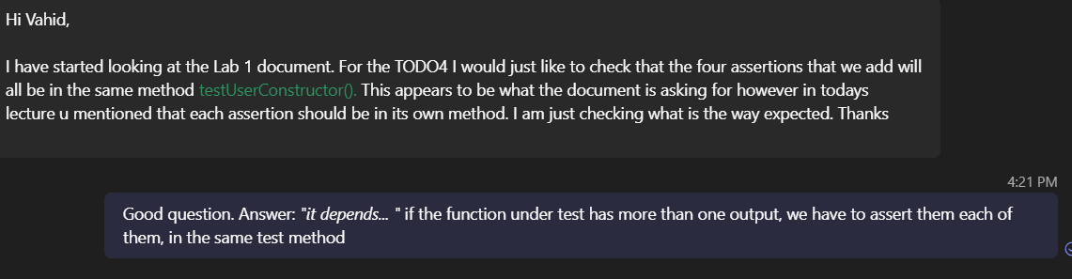We are not saying that a test method should not have multiple assertions. It can have and it’s not a problem if the above is the case (if all asserts belong to one single test case). But several test cases should not be combined into one test method.

## Can we use JUnit assertEquals() instead of regular asserts? No!

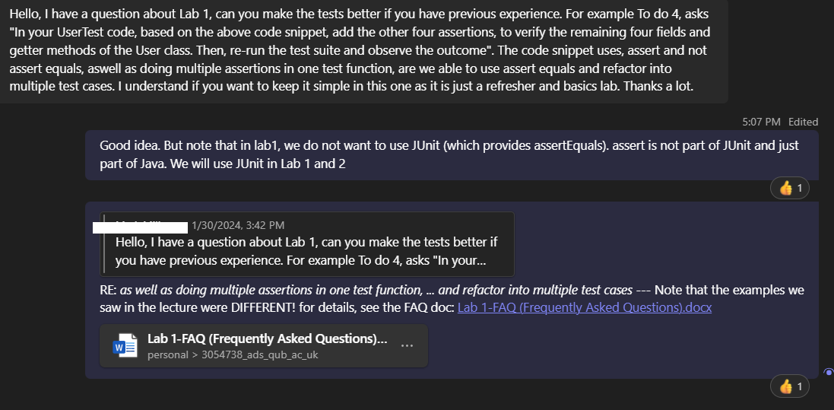

# Non-technical FAQ (Project set-up, etc)

## Error message "Could not find or load main class” in Java / Eclipse

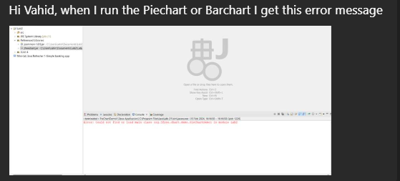

Your project set up in the IDE has issues, or you need to use Eclipse in the right way. ... See:

<https://www.google.com/search?q=eclipse+java+could+not+find+or+load+main+class>

## *Code screenshots*

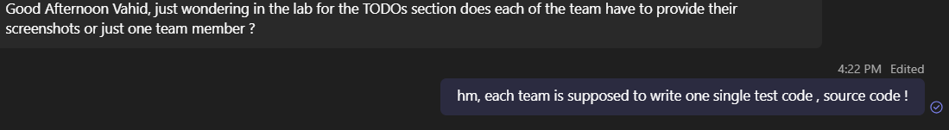

## *“I was wondering if we could use [the] IntelliJ [IDE] for the lab assignment?”*

Answer: There is a section in the lab document about this issue.

## GitHub

### GitHub repository set up

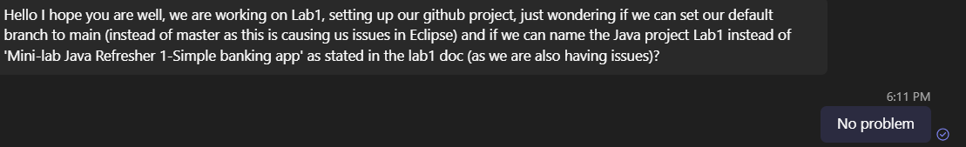

### How to upload code to GitHub

The best way is to use *GitHub Desktop* <https://desktop.github.com/>

And many videos on how to use it: <https://www.google.com/search?q=github+desktop+how+to+use>

### Can we use any email address for our GitHub accounts?

Obviously yes